FOR IMMEDIATE RELEASE March 26, 2012

“HAWAII A VOICE FOR SOVEREIGNTY”
THEATRICAL SCREENING & PRESS EVENT

Time: 11 am
Date: March 31, 2012
Place: Laemmle’s Playhouse 7, Pasadena CA.
Contact: Othila Media Productions
Catherine Bauknight • 626-786-4227
RSVP to cbauknight@othilamedia.comz

Hawaii A Voice For Sovereignty, the seven - time award winning documentary film will host a free theatrical screening and press event at the Laemmle’s Playhouse 7 in Pasadena, California March 31st, 2012 at 11:00 am.

After the 83-minute film, there will be a Q&A panel and discussion with honored guest Hawaiian activist Leon Siu, Minister of Foreign Affairs for the Hawaiian Kingdom. Mr. Siu is working to revive still-existing treaties and developing diplomatic relations for the Hawaiian Kingdom. He will be attending the screening having just returned from a U.N. Conference in Geneva and will be reporting recent developments in the Hawaiian Sovereignty Movement, including legislation introduced in Hawaii State Legislature 68/House Concurrent Resolution 96, which recognizes Hawaiian Nationals as a population residing lawfully in the Hawaiian Islands. This resolution was passed in the House Committee on Hawaiian Affairs on March 21st, 2012.

Also on the panel is Hawaii A Voice For Sovereignty filmmaker, Catherine Bauknight, a photojournalist whose work has been featured in TIME Magazine, Newsweek, NY Times, and the LA Times. She has covered events such as the Tiananmen Square Massacre, Bad Water in Ethiopia, and the Renaissance of the Catawba Indians.

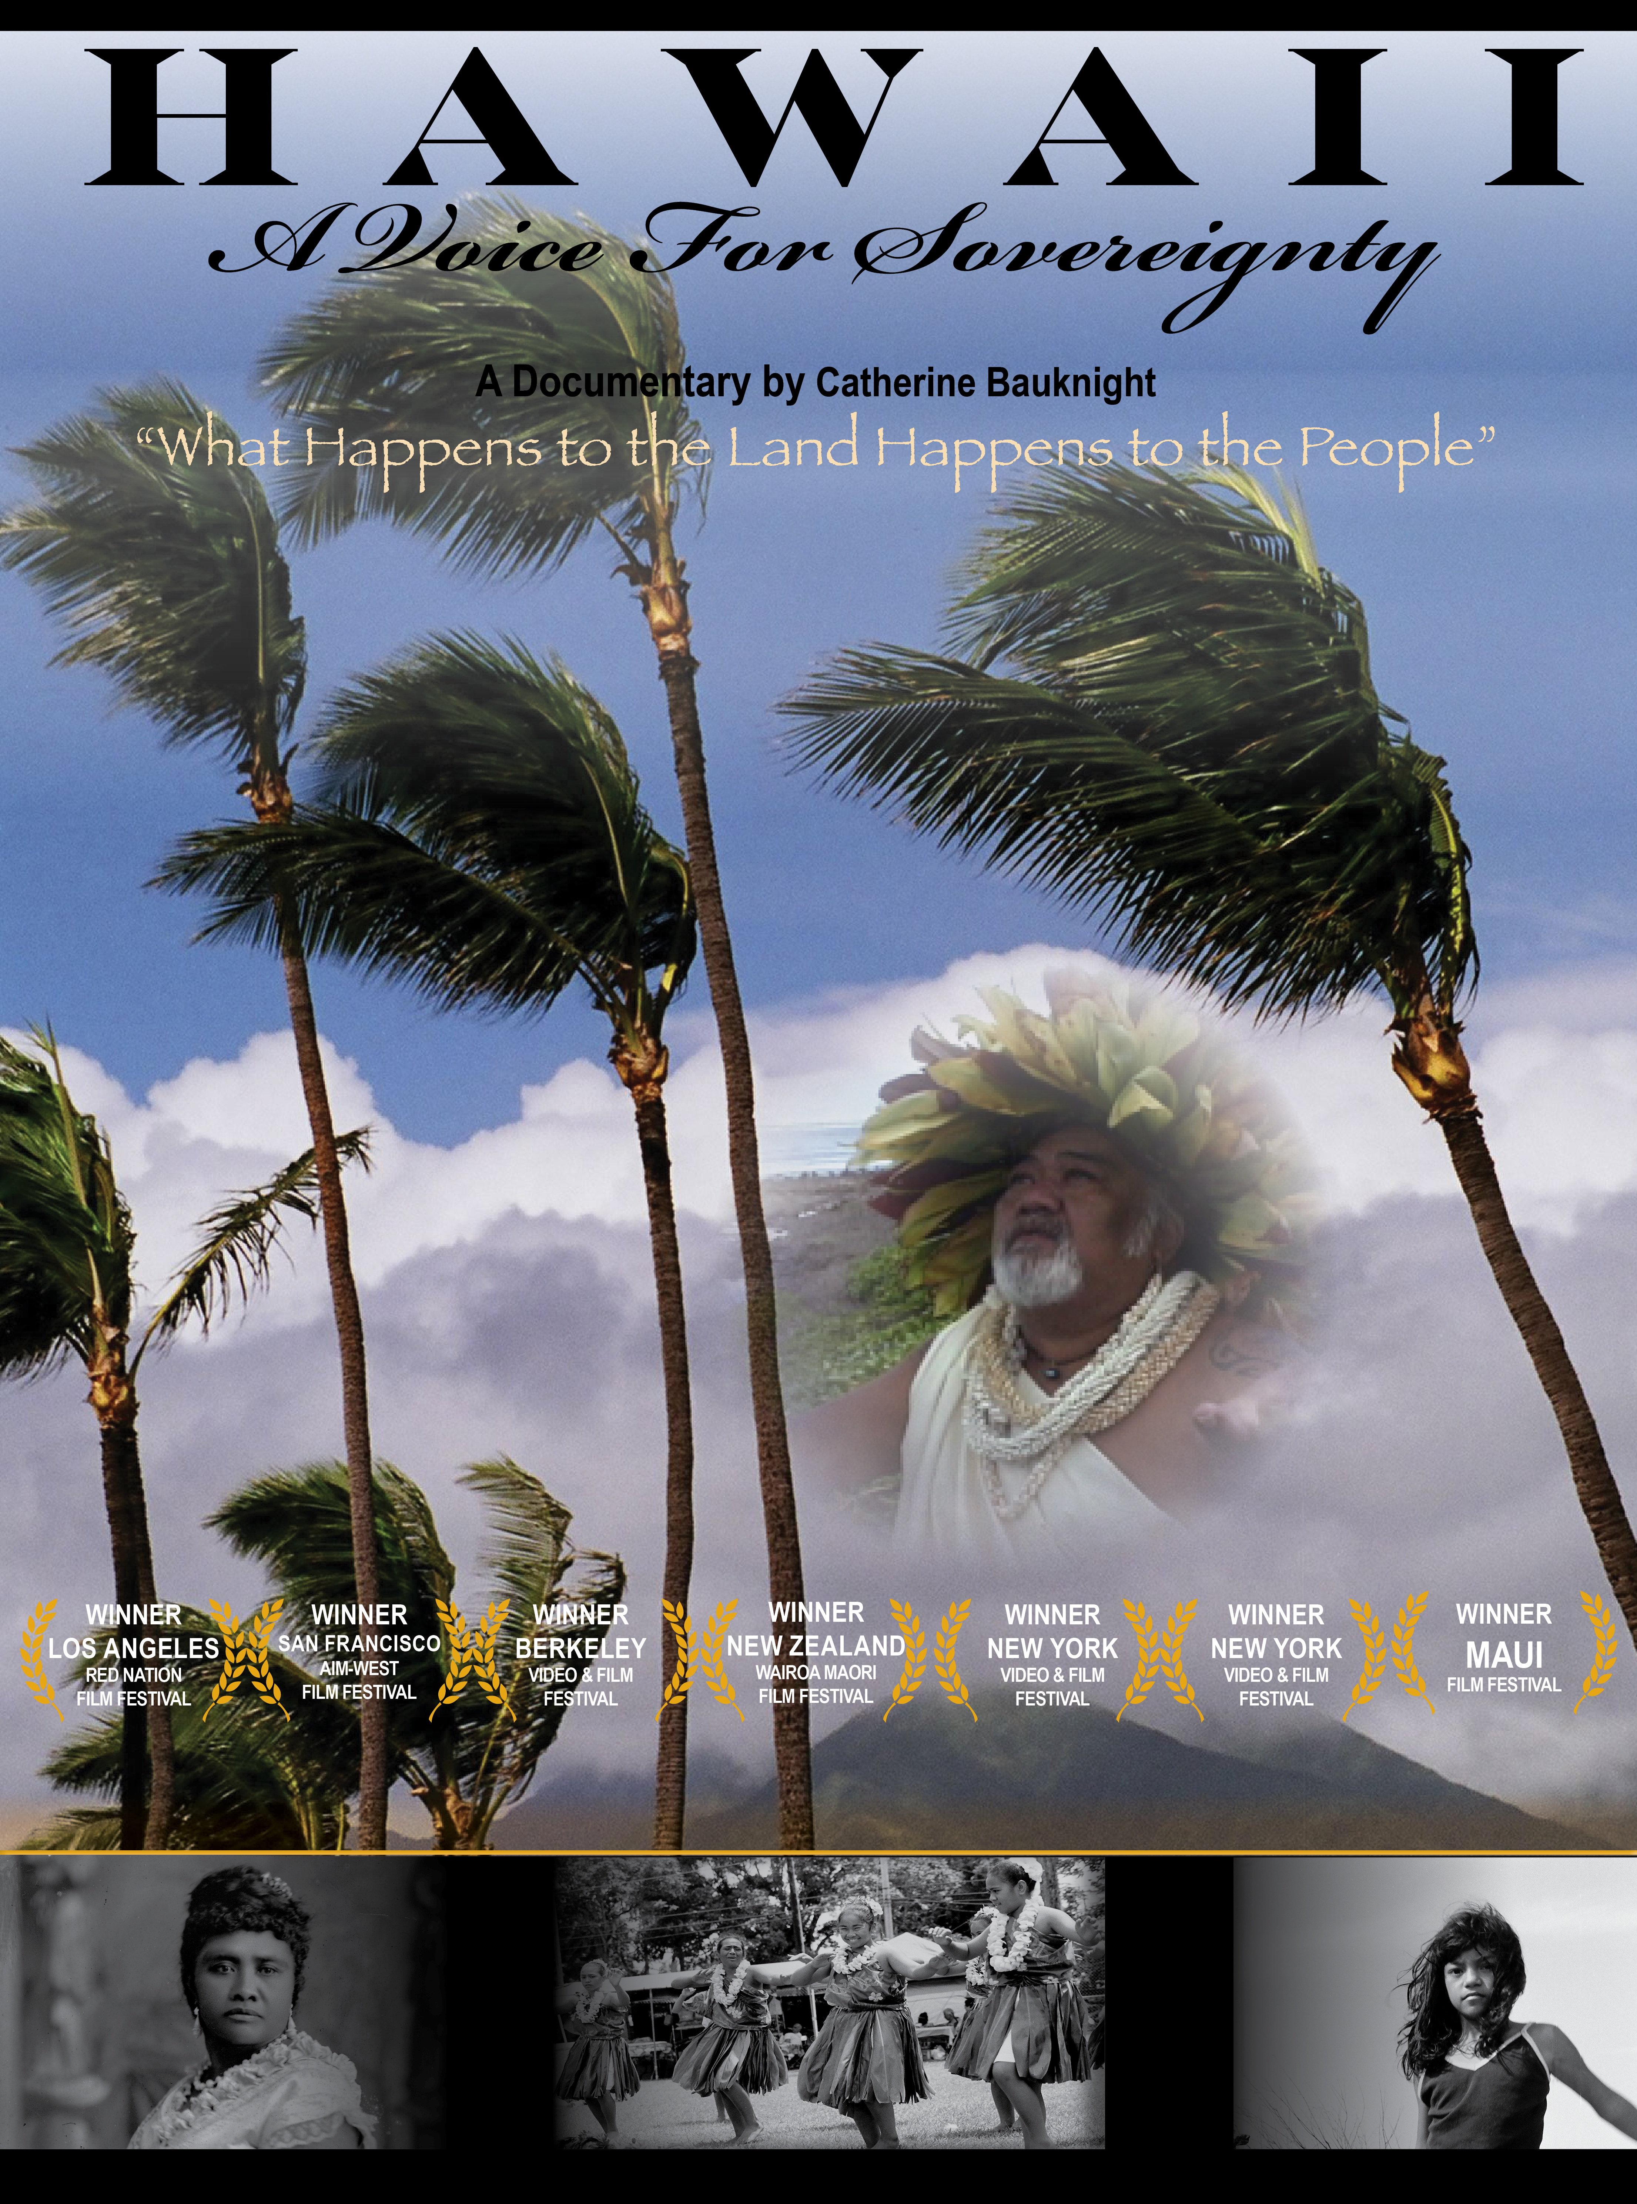
The panel will be moderated by 'Ehu Kekahu Cardwell, co-host of “Voices of Truth-One on One with Hawai'i's Future”, The Koani Foundation's award winning television and internet show, and commentor on Free Hawai'i TV.` Robert Scheer, renowned journalist, editor in chief of Truthdig and author will also be a panel guest. Ed Rampell, film critic and author will speak about his coverage of the early Hawaiian Sovereignty Movement and the significance of the film. Also on the panel is Hawaiian Activist Dr. Hanalei Vierra.

The film took four years to shoot and explores the Hawaiian culture, spirituality, and their close connection to the land. At the forefront of the film are the complicated social, economic, and ecological issues that have developed in Hawaii since the overthrow by U.S. Marines and U.S. businessmen in 1893. The native Hawaiians in the film address the issues they continue to face in their long struggle to regain sovereign rights and native lands lost after the overthrow. Cast includes grassroots indigenous Hawaiians and scholars such as: Dr. Haunani-Kay Trask, Professor Kaleikoa Ka’eo, Hawai`i State Senator Kalani English, Clifford Nae’ole, Ramsay Taum, Kahu Hanalei Colleado. Ke’eaumoku Kapu, Grammy award winning musician Willie K, and New York Times Best selling author Gregg Braden. The goal of the documentary is to raise awareness regarding the issues that threaten the Hawaiian’s ancient, once-environmentally-sustainable culture and land.

Hawaii A Voice for Sovereignty’s digital distribution company in North America is GAIAM Inc. and will launch on GAIAM TV, iTunes, Amazon LOVEFiLM and Netflix in 2012. A portion of proceeds generated by the film will be donated to Pasifika Foundation Hawai`i .

Admission to the event is FREE.
For more information and RSVP to cbauknight@othilamedia.com - no later than March 28th.
Location - Laemmle’s Playhouse 7 Theater, 673 East Colorado Blvd. Pasadena, CA. 310-478-3836

To view the trailer and purchase the DVD and soundtrack CD go to http://www.hawaiiavoiceforsovereignty.com

